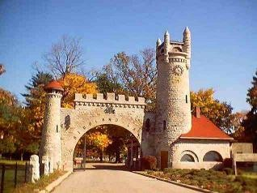

Cemetery Board Meeting
Tuesday, January 7, 2020
1:00pm Special Call 1:15pm meeting
Cemetery Office, Highland Lawn Cemetery

1. Call to Order

2. Welcoming Remarks

3. Approve Claims, Collections and Minutes

4. Old Business
a. Budget

b. Dates for 2020 meetings

5. New Business
a.

6. Announcements

7. Public comment on non-agenda items – (limited to 5 minutes)

9. Adjournment

Next Meeting:
Wednesday, February, 12, 2020
Meeting 1:15 pm
Cemetery Office, Highland Lawn Cemetery

Any individual who requires an auxiliary aid or service for effective communication, or a modification of policies or procedures to participate in a public meeting, program, service, or activity of the City of Terre Haute, should contact Melissa Reed at the Human Relations Department, 17 Harding Ave, Terre Haute, IN 47807, (812) 244-5611, as soon as possible, but no later than 48 hours before the scheduled event.

